Day 18 (18 July 2025)
112552596 - vsisukhw - Sukhwinder Singh

For tasks questions , refer
https://docs.google.com/document/d/1StbM4TkJCetofLiqsYWcpdgcgP7Zhm-nizxOpp6Y-NM/edit?tab=t.0

Task 1
What kind of collision resolution strategy is implemented in the below Hash Table ?
import java.util.*;

class Task01 {

LinkedList<Entry>[] data = new LinkedList[10];

public void put(String keyval, int value) {
int index = Math.abs(keyval.hashCode() % data.length);

if (data[index] == null) {
data[index] = new LinkedList<>();
}
for (Entry e : data[index]) {
if (e.keyval.equals(keyval)) {
e.value = value;
return;
}
}

data[index].add(new Entry(keyval, value));
}

static class Entry {
String keyval;
int value;

Entry(String k, int v) {
keyval = k;
value = v;
}
}
}

is it using

to fill collisions is it linear probing with backtracking

or
Opening address by placing values at next available bucket

or
at each index chaining using a linked list

or
on each collision resizing hash table

If a collision occurs (same index for multiple keys), the new key–value pair is added to the linked list at that index.
So multiple entries at the same index are stored as a linked list — this is classic separate chaining.
So, Correct Option - At each index chaining using a linked list
Task 2
Wap to take input from the user a 5 digit no and display digit by digit in the output

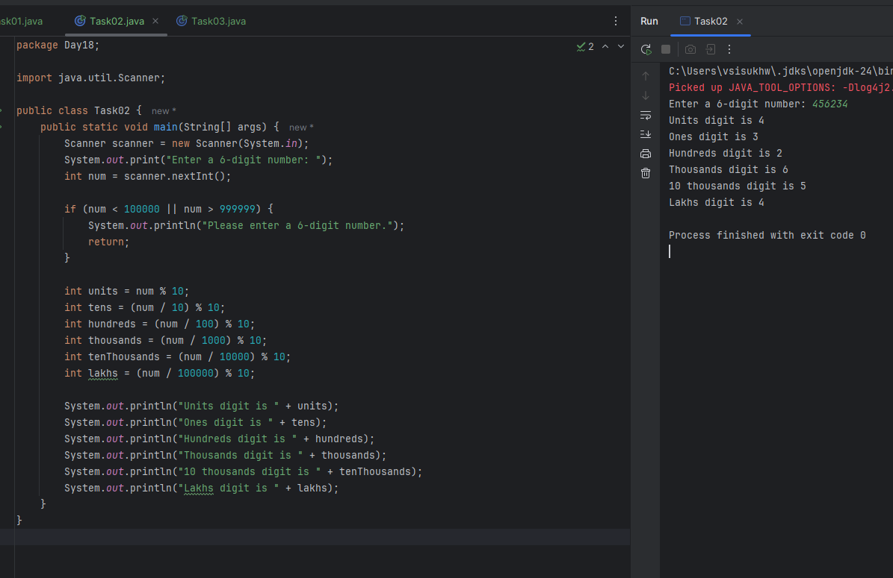
Task 3
Wap to take number from the user and display the no of digit it has .

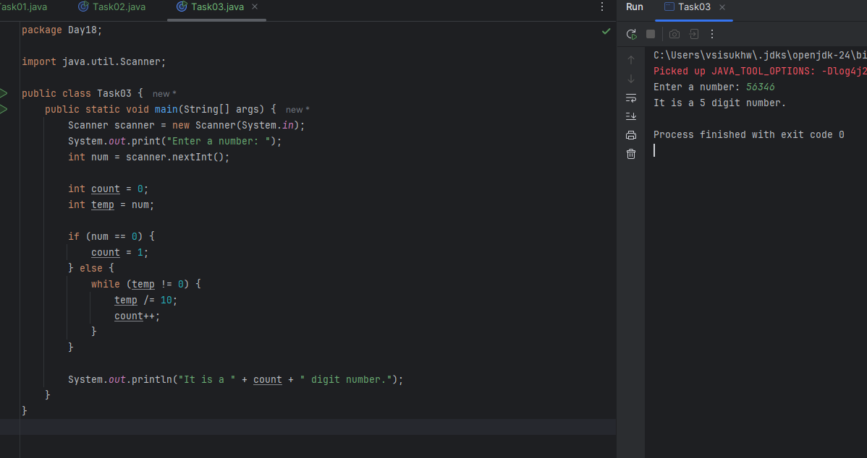

Task 4

Applications of Heap Sort (In Brief):
- Priority Queues
  - Basis for implementing priority queues used in scheduling and networking.
- Real-Time Systems
  - Guarantees O(n log n) performance even in the worst case — suitable for time-critical systems.
- Memory-Constrained Devices
  - In-place sorting with O(1) extra space — ideal for embedded systems.
- Job Scheduling in OS
  - Used to manage tasks/jobs by priority (e.g., highest priority task first).
- Graph Algorithms
  - Supports algorithms like Dijkstra’s and Prim’s using heaps.
- Event-Driven Simulations
  - Processes events in time order using a heap-based event queue.
- Finding Kth Largest/Smallest
  - Efficient for problems where you need to find top-k elements.
- External Sorting
  - Used for merging large sorted data chunks that don’t fit in memory.

Task 5
Do you find any significant change between the breadthFirstSearchRecursive() approach compared to the standard BFS?
Answer:
Yes, the recursive BFS achieves the same level-order traversal result as standard BFS but uses a recursive structure with an explicitly passed queue. It does not eliminate the need for queues, nor does it rely on the call stack like DFS. It also does not process nodes in post-order.
Correct Option - It achieve same result but emphasizes on recursive style using the same level-order logic with explicit queue management.

Task 6
How does heap sort work ? explain the technique in 5 steps.. Algorithm

Heap Sort – 5 Step Technique
- Build a Max Heap from the input array.
- Swap the root (largest element) with the last element.
- Reduce the heap size by one.
- Heapify the root to maintain max-heap property.
- Repeat steps 2–4 until the heap is fully sorted.

Task 7
How do recursive functions maintain the state of each call during execution?
Answer:
The system call stack tracks local variables and return addresses for each recursive invocation.
Each recursive call gets its own stack frame, allowing the program to remember where it left off and resume correctly after each call.

Task 8

Which property of a priority queue differentiates it most from a regular queue implementation?
- It allows insertion and removal only from one end, similar to a stack.
- Elements are removed based on their order of insertion rather than priority.
- Elements are dequeued based on their priority, not their insertion order, often implemented using a binary heap.
- It maintains a strict hierarchical structure using a self-balancing BST to enforce priority.
Correct Answer: 3. Elements are dequeued based on their priority, not their insertion order, often implemented using a binary heap.

Task 9
What is the main purpose of using a binary heap in the implementation of a priority queue?
- To maintain keys in alphabetical order for efficient string processing.
- To ensure that the highest-priority element always bubbles to the root efficiently.
- To guarantee constant-time insertion and logarithmic-time deletion.
- To reduce memory consumption by flattening the tree into a linear array.
Correct Answer: 2. To ensure that the highest-priority element always bubbles to the root efficiently.

Task 10
Can you print the corner nodes of a binary search tree?

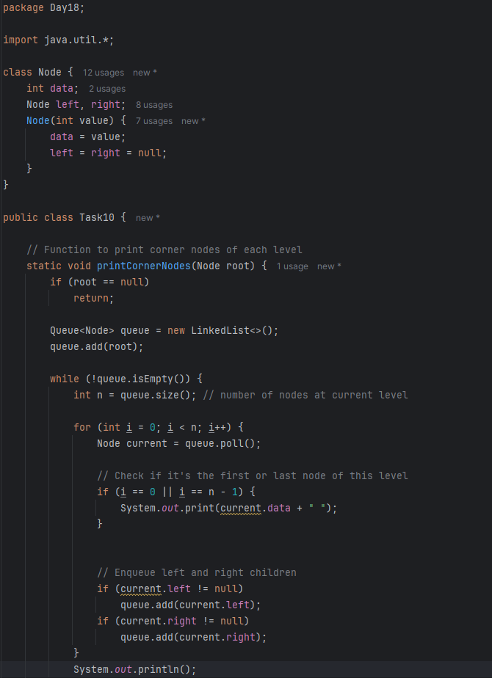
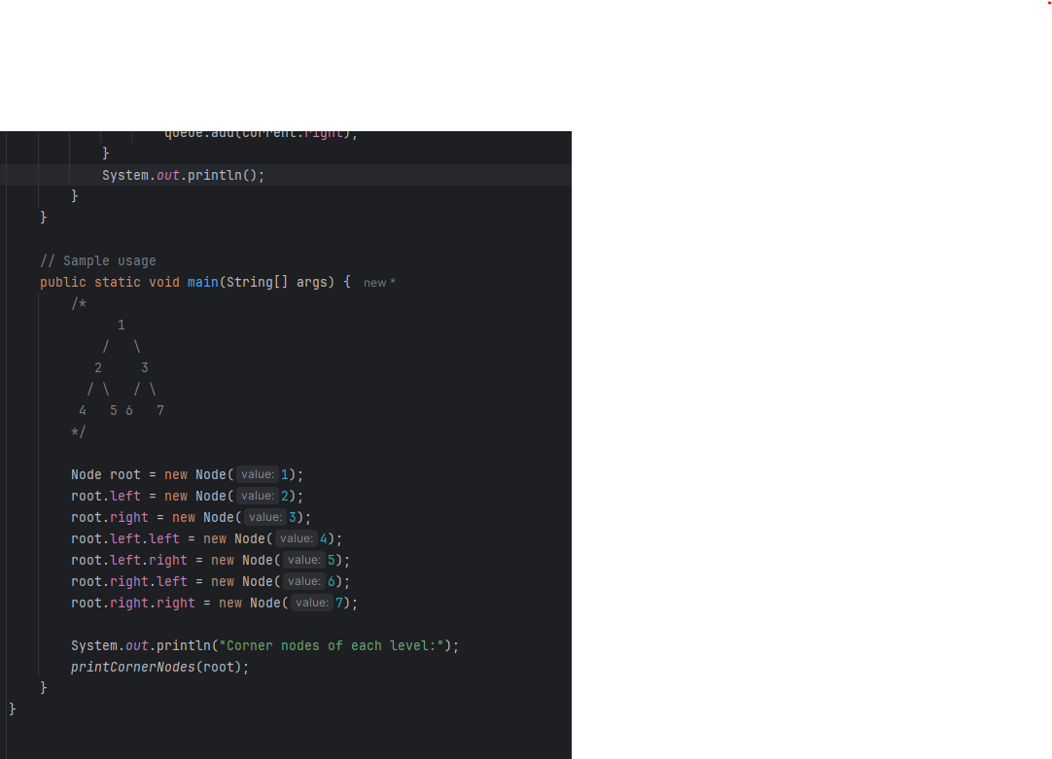

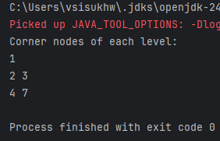

Task 11
Which concept explains how recursive functions maintain the state of each call during execution?
- Each recursive call creates a new thread, and context switching maintains state.
- Recursive functions store state in global variables accessible across calls.
- The system call stack tracks local variables and return addresses for each recursive invocation.
- Recursive functions replicate the heap structure to keep values between calls
Correct Answer: 3. The system call stack tracks local variables and return addresses for each recursive invocation.

Task 12

How does this binary search function behave on unsorted arrays?
public class BinarySearch {
public int search(int[] arr, int target) {
int left = 0, right = arr.length - 1;

while (left <= right) {
int mid = left + (right - left) / 2;

if (arr[mid] == target) {
return mid;
} else if (arr[mid] < target) {
left = mid + 1;
} else {
right = mid - 1;
}
}

return -1;
}
}

- It works regardless of sorting
- It throws exception if unsorted
- It may return incorrect index
- It sorts before searching
Correct Answer: 3. It may return incorrect index

Task 13
What is the result of performing DFS traversal in this graph implementation?
import java.util.*;

public class DFSGraph {

Map<Integer, List<Integer>> adj = new HashMap<>();

Set<Integer> visited = new HashSet<>();

public void addEdge(int u, int v) {
adj.computeIfAbsent(u, x -> new ArrayList<>()).add(v);
}

public void dfs(int node) {
if (visited.contains(node)) {
return;
}

visited.add(node);
System.out.print(node + " ");

for (int neighbor : adj.getOrDefault(node, new ArrayList<>())) {
dfs(neighbor);
}
}
}

- DFS uses a queue to ensure order
- DFS will return shortest path like BFS
- DFS traverses all nodes depth-first recursively
- DFS skips connected nodes due to reentrancy issue
Correct Answer: 3. DFS traverses all nodes depth-first recursively

Task 14
Why is BFS generally preferred over DFS in shortest path algorithms for unweighted graphs?
- BFS uses random access to edges, ensuring constant-time traversal.
- BFS explores one path to maximum depth before switching, reducing memory usage.
- BFS ignores revisiting nodes, reducing processing time in cyclic graphs.
- BFS explores nodes in increasing distance order from the source, ensuring shortest paths are found first.
Correct Answer: 4. BFS explores nodes in increasing distance order from the source, ensuring shortest paths are found first.

Task 15
Algorithm:
Start with the input array and find the maximum number to know the number of digits.
Initialize a variable exp = 1 (for the least significant digit).
Repeat the following steps while max / exp > 0:
- Create 10 buckets (queues or lists) for each digit (0 to 9).
- Place each number in the array into the corresponding bucket based on the digit at exp place.
For example, (number / exp) % 10 gives the current digit.
- Flatten all buckets back into the array, maintaining order.
- Multiply exp by 10 to move to the next significant digit.
Repeat this until all digits are processed.
Print or return the sorted array.

Task 16
Pseudocode:

Function radixSort(arr, n):
max ← findMaximum(arr, n)
exp ← 1
while max / exp > 0 do:
countSortByDigit(arr, n, exp)
exp ← exp × 10
End Function

Function countSortByDigit(arr, n, exp):
output ← array of size n initialized to 0
count ← array of size 10 initialized to 0
for i ← 0 to n - 1 do:
index ← (arr[i] / exp) % 10
count[index] ← count[index] + 1
for i ← 1 to 9 do:
count[i] ← count[i] + count[i - 1]
for i ← n - 1 down to 0 do:
index ← (arr[i] / exp) % 10
output[count[index] - 1] ← arr[i]
count[index] ← count[index] - 1
for i ← 0 to n - 1 do:
arr[i] ← output[i]
End Function

Task 17
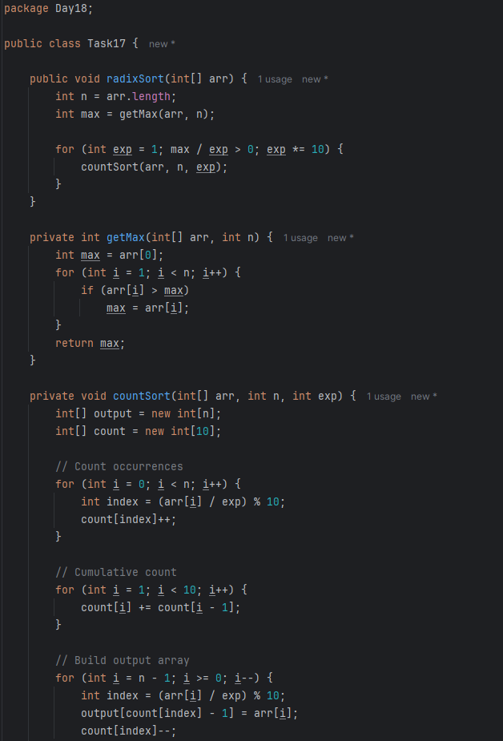
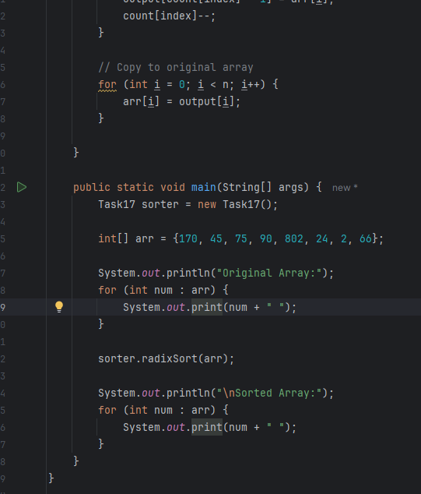
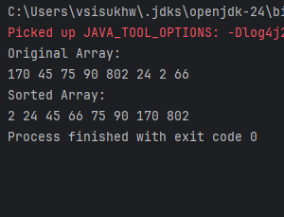

Task 18
What causes a stack overflow error in recursive functions?
- Excessive memory allocation in the heap due to global variables.
- Infinite iteration loops that do not update the loop variable.
- Recursion that lacks a proper base case or makes too many nested calls, exhausting the call stack.
- Function calls that return too quickly without completing the recursion tree.
Correct Answer: 3. Recursion that lacks a proper base case or makes too many nested calls, exhausting the call stack.

